

**Class :-12th Sci/Commerce Information Technology Teacher : Mrs. Shilpa Kate**

**Exercise solution: Lesson No.1. Advanced Web designing** 

**Q 1. Fill in the blanks.**

1. The **<!doctype html>**element is a starting element in an HTML, it indicates that document type definition being used by the document.

1. The **<meta>** is a tag in html that describes some aspects of the contents of a webpage.
2. The <ol> tag defines an **ordered list**
3. An unordered list created using the **<ul>** tag
4. The **<iframe>** element creates an inline frame.
5. **<video>** .tag is used to specify video on an HTML document.
6. If a web developer wants to add the description to an image he must use **alt** attribute of <img> tag.
7. The **position**  property is used to set position for an element.
8. The float property defines the **flow** of content.
9. **Position**  is used with elements that overlap with each other.

**Q2. State whether the following statement is True or False**

1. HTML is an Object Oriented Programming Language.

**Ans:: False**

1. Charset is used for character encoding declaration.

**Ans: True**

1. An unordered list can be numerical or alphabetical.

**Ans:False**

1. Multilevel list can be created in HTML 5.

**Ans:: True**

1. Srccode specifies the HTML content of the page to show in the <iframe>

Ans:False

1. The ‘controls’ attribute is not used to add play, pause, and volume.

**Ans:: False**

1. .cs is the extension of CSS file (**.css** not .cs)

Ans:: False

**Q3. Choose Single correct answer from the given options.**

1. . ………………….element used to create a linking image

a) <img> b) <td> d) <usemap > **c) <map>**

1. The ……………tag is used to embed audio files on Webpages.

a.) <sound> **b) <audio>** c)<video> d) <embedded>

1. A programmer wants to define range for age between 18 to 50, he will use a form with following appropriate control.

a) number b ) compare d) Textboxes **c) range**

1. . ……….character is used to create id in CSS.

a) % b)$ c)@ **d)#**

**Q 4. Choose Two correct answers from the given options.**

1. List within another list either …..list or ….list is called nested list.

a. Multilevel **b)order c)unordered** d)general e)cascading

2.Image maps are of two types …….and……..

a. Network side **b)client side** c)computer lab **d)Server side** e)n-computing

3.A CSS rule set contains …………………and……………

a. set **b. selector** c. post **d. declaration** e.block

4.Client-side image map can be created using two elements …….and…….

**a) <area>** b)<image> c)<usemap> **d.<map>** e.<server>

**5. Choose Three correct answers from the given options.**

1. Attributes of <area> tag is……………………..

**a)href** b)src **c)coords** d)data e)alt f)usemap

2. Attributes used with iframe ….

**a) srcdoc b) name** **d) src** f) loop c) att e) href

3. following are the form controls

**a)email** **b)search** c)label d)video **e)tel** f) audio

4. Attributes used with <audio> tag…………

**a)Autoplay** b)href **c)controls** d)cntrl **e)loop** f) bgsound

5. CSS types are …………………, ………...... and…………………

**a) internal b) external** c) control **d) inline** e) loop f) style

6. Positioning types in CSS are

**a) Static c) absolute** e) dynamic **b) fixed**

d)position f) nested

7.Types of floating properties are…………..

**a) left**  b)zero **c)right**  d)all **e)none** f)dock

Q. 6. Match the pair

A

**1)<ul>**

1. **usemap**
2. **color**
3. **<Img>**

**5) <Input type =image>**

Q.7 Programs

**1) Write a program using html with following CSS specification-**

1. **The background colour of the company name should be in green.**
2. **The text colour of the company name should be red.**
3. **The heading should be large with font ''comic sans ms''**
4. **The description of the company should be displayed in blue color in a paragraph.**

**<!doctype html>**

**<html>**

**<head> <title> First program</title>**

**<style>**

**h1{ background-color:green;color:red;font-family:comic sans ms;text-align:center;}**

**p{color:blue;}**

**</style></head>**

**<body>**

**<h1>S B Patil group</h1>**

**<p> There are multiple branches comes under S B Patil group. S B Patil science and commerce is one of the best junior college in Pune. Students of this college are very talent and innovative.**

**</p>**

**</body>**

**</html>**

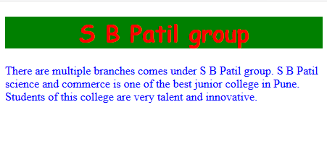

**2. Write Html5 code with CSS as follows-**

**1. To create form to accept name,age,email-address, from the user.**

**2.create a submit button to send the data**

**3. The heading of the form should have background colour and a different font style**

<!doctype html>

<html>

<head><title>program2</title>

<style>

h1{background-color:blue; font-style:italic; color:yellow;}

</style> </head>

<body style="text-align:center" >

<h1>Registration form</h1>

<form name="f1">

Enter Name:<input type="text" name="name"><br><br>

Enter Age:<input type="number" name="age"><br><br>

Enter Email:<input type="email" name="email"><br><br>

<input type="submit" name="submit" value="ok">

</form>

</body></html>

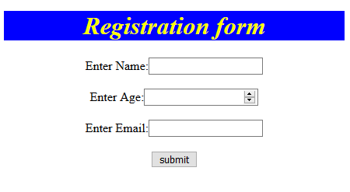

**3.Write HTML5 code with CSS as follows-**

1. **Create ordered list with names of tourist Cities.**
2. **Create unordered list with tourist places of those cities.**
3. **Divide the list into two sections left and right by using CSS.**

<!doctype html>

<html>

<head>

<title>list demo</title>

<style>

.left{background-color:skyblue;float:left;width:50%;}

.right{float:right;background-color:yellow;width:50%;}

</style>

</head>

<body>

<div class="left" >

<ol>

<li>Aurangabad</li>

<li>pune</li>

<li>Mumbai</li>

<li>Kolhapur</li>

<li>Goa</li>

</ol>

</div>

<div class="right">

<ul>

<li>Ajanta and Allora caves</li>

<li>Bibi ka maqbara</li>

<li>Daulatabad fort</li>

<li>Shaniwarwada</li>

<li>Gateway of India</li>

</ul>

</div>

</body>

</html>

**Output**

